The Literature Review: A Research Journey
This guide is an introduction to the basics of conducting a literature review in the social sciences, with a focus on education.
Table of Contents
Literature Review Guide Evaluation

Synthesize
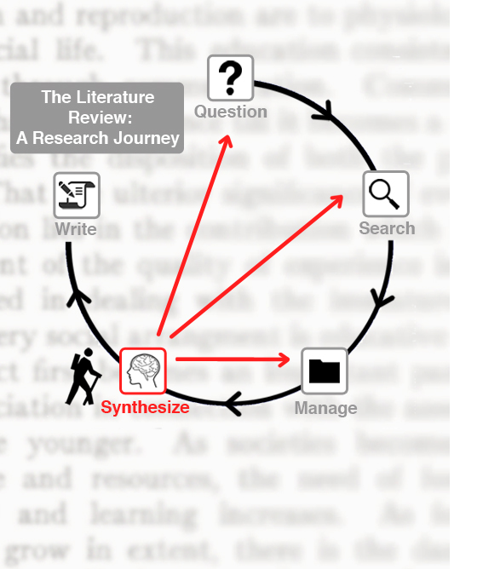 | Definition:  To synthesize is to combine two or more elements to form a new whole. In the literature review, the “elements” are the findings of the literature you gather and read; the “new whole” is the conclusion you draw from those findings.  Purpose:  Synthesize to draw conclusions about the findings in the literature so that you can identify how the literature addresses your research question.  Process:  - Gather literature that addresses your research question  - Review literature and take notes: describe, summarize, analyze, and identify key concepts  - Synthesize literature: compare & contrast, critically evaluate, interpret, so that you can draw conclusion  Remember: the literature review is an iterative process!

Synthesize E-Lecture (4:41)


Faculty & Student Voices (2:09)
<span itemprop="name" content="Synthesize2"></span>< span itemprop="description" content="null"></span>< span itemprop="duration" content="129"></span>< span itemprop="thumbnail" content="http://cfvod.kaltura.com/p/1633051/sp/163305100/thumbnail/entry_id/1_2e7laicv/version/100001"></span>< span itemprop="width" content="560"></span>< span itemprop="height" content="395"></span>
how_to

